| Please choose a lesson, or type 0 to return to course menu.

1: Principles of Analytic Graphs 2: Exploratory Graphs

3: Graphics Devices in R 4: Plotting Systems

5: Base Plotting System 6: Lattice Plotting System

7: Working with Colors 8: GGPlot2 Part1

9: GGPlot2 Part2 10: GGPlot2 Extras

11: Hierarchical Clustering 12: K Means Clustering

13: Dimension Reduction 14: Clustering Example

15: CaseStudy

Selection: 5

| | 0%

| Base_Plotting_System. (Slides for this and other Data Science courses may be found at github

| https://github.com/DataScienceSpecialization/courses/. If you care to use them, they must be

| downloaded as a zip file and viewed locally. This lesson corresponds to

| 04_ExploratoryAnalysis/PlottingBase.)

...

|= | 2%

| In another lesson, we gave you an overview of the three plotting systems in R. In this lesson we'll

| focus on the base plotting system and talk more about how you can exploit all its many parameters to

| get the plot you want. We'll focus on using the base plotting system to create graphics on the

| screen device rather than another graphics device.

...

|=== | 3%

| The core plotting and graphics engine in R is encapsulated in two packages. The first is the graphics

| package which contains plotting functions for the "base" system. The functions in this package

| include plot, hist, boxplot, barplot, etc. The second package is grDevices which contains all the

| code implementing the various graphics devices, including X11, PDF, PostScript, PNG, etc.

...

|==== | 5%

| Base graphics are often constructed piecemeal, with each aspect of the plot handled separately

| through a particular function call. Usually you start with a plot function (such as plot, hist, or

| boxplot), then you use annotation functions (text, abline, points) to add to or modify your plot.

...

|====== | 6%

| Before making a plot you have to determine where the plot will appear and what it will be used for.

| Is there a large amount of data going into the plot? Or is it just a few points? Do you need to be

| able to dynamically resize the graphic?

...

|======= | 8%

| What do you think is a disadvantage of the Base Plotting System?

1: A complicated plot is a series of simple R commands

2: It mirrors how we think of building plots and analyzing data

3: You can't go back once a plot has started

4: It's intuitive and exploratory

Selection: 3

| Perseverance, that's the answer.

|========= | 9%

| Yes! The base system is very intuitive and easy to use. You can't go backwards, though, say, if you

| need to readjust margins or have misspelled a caption. A finished plot will be a series of R

| commands, so it's difficult to translate a finished plot into a different system.

...

|========== | 11%

| Calling a basic routine such as plot(x, y) or hist(x) launches a graphics device (if one is not

| already open) and draws a new plot on the device. If the arguments to plot or hist are not of some

| special class, then the default method is called.

...

|=========== | 12%

| As you'll see, most of the base plotting functions have many arguments, for example, setting the

| title, labels of axes, plot character, etc. Some of the parameters can be set when you call the

| function or they can be added later in a separate function call.

...

|============= | 14%

| Now we'll go through some quick examples of basic plotting before we delve into gory details. We'll

| use the dataset airquality (part of the library datasets) which we've loaded for you. This shows

| ozone and other air measurements for New York City for 5 months in 1973.

...

|============== | 15%

| Use the R command head with airquality as an argument to see what the data looks like.

> head(airquality)

Ozone Solar.R Wind Temp Month Day

1 41 190 7.4 67 5 1

2 36 118 8.0 72 5 2

3 12 149 12.6 74 5 3

4 18 313 11.5 62 5 4

5 NA NA 14.3 56 5 5

6 28 NA 14.9 66 5 6

| You nailed it! Good job!

|================ | 17%

| We see the dataset contains 6 columns of data. Run the command range with two arguments. The first is

| the ozone column of airquality, specified by airquality$Ozone, and the second is the boolean na.rm

| set equal to TRUE. If you don't specify this second argument, you won't get a meaningful result.

> range(airquality$Ozone, na.rm = TRUE)

[1] 1 168

| Excellent job!

|================= | 18%

| So the measurements range from 1 to 168. First we'll do a simple histogram of this ozone column to

| show the distribution of measurements. Use the R command hist with the argument airquality$Ozone.

> hist(airquality$Ozone)

| Nice work!

|=================== | 20%

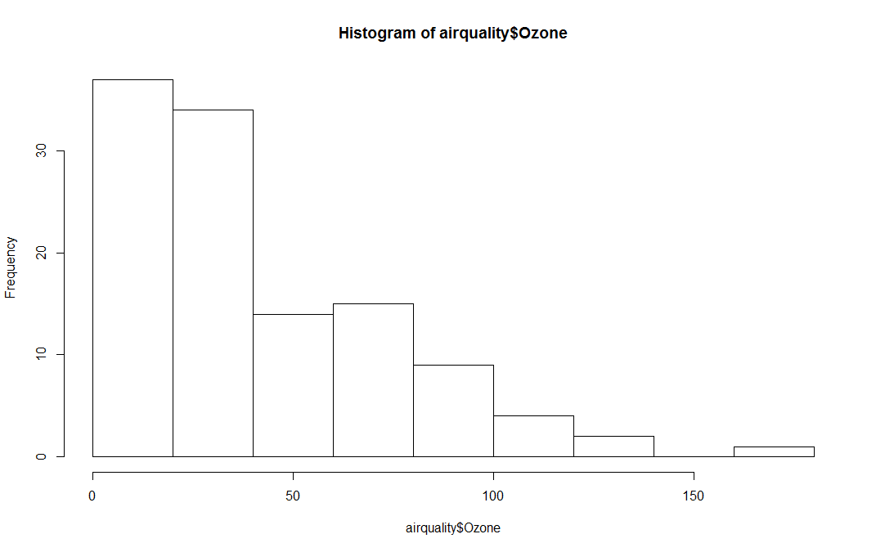

| Simple, right? R put a title on the histogram and labeled both axes for you. What is the most

| frequent count?

1: Under 25

2: Between 60 and 75

3: Over 100

4: Over 150

Selection: 1

| You got it right!

|==================== | 21%

| Next we'll do a boxplot. First, though, run the R command table with the argument airquality$Month.

> table(airquality$Month)

5 6 7 8 9

31 30 31 31 30

| You are quite good my friend!

|===================== | 23%

| We see that the data covers 5 months, May through September. We'll want a boxplot of ozone as a

| function of the month in which the measurements were taken so we'll use the R formula Ozone~Month as

| the first argument of boxplot. Our second argument will be airquality, the dataset from which the

| variables of the first argument are taken. Try this now.

> boxplot(Ozone~Month, airquality)

| Nice work!

|======================= | 24%

| Note that boxplot, unlike hist, did NOT specify a title and axis labels for you automatically.

...

|======================== | 26%

| Let's call boxplot again to specify labels. (Use the up arrow to recover the previous command and

| save yourself some typing.) We'll add more arguments to the call to specify labels for the 2 axes.

| Set xlab equal to "Month" and ylab equal to "Ozone (ppb)". Specify col.axis equal to "blue" and

| col.lab equal to "red". Try this now.

> boxplot(Ozone~Month, airquality, xlab = "Month", ylab = "Ozone (ppb)", col.axis = "blue", col.lab = "red")

| You got it right!

|========================== | 27%

| Nice colors, but still no title. Let's add one with the R command title. Use the argument main set

| equal to the string "Ozone and Wind in New York City".

> title(main = "Ozone and Wind in New York City")

| All that hard work is paying off!

|=========================== | 29%

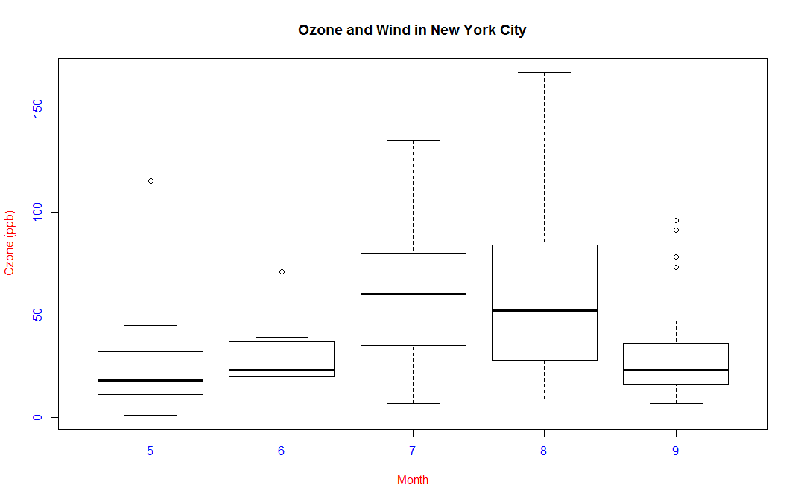

| Now we'll show you how to plot a simple two-dimensional scatterplot using the R function plot. We'll show

| the relationship between Wind (x-axis) and Ozone (y-axis). We'll use the function plot with those two

| arguments (Wind and Ozone, in that order). To save some typing, though, we'll call the R command with

| using 2 arguments. The first argument of with will be airquality, the dataset containing Wind and Ozone;

| the second argument will be the call to plot. Doing this allows us to avoid using the longer notation,

| e.g., airquality$Wind. Try this now.

> with(airquality, plot(Wind, Ozone))

| That's correct!

|============================ | 30%

| Note that plot generated labels for the x and y axes but no title.

...

|============================== | 32%

| Add one now with the R command title. Use the argument main set equal to the string "Ozone and Wind in New

| York City". (You can use the up arrow to recover the command if you don't want to type it.)

> title(main = "Ozone and Wind in New York City")

| You nailed it! Good job!

|=============================== | 33%

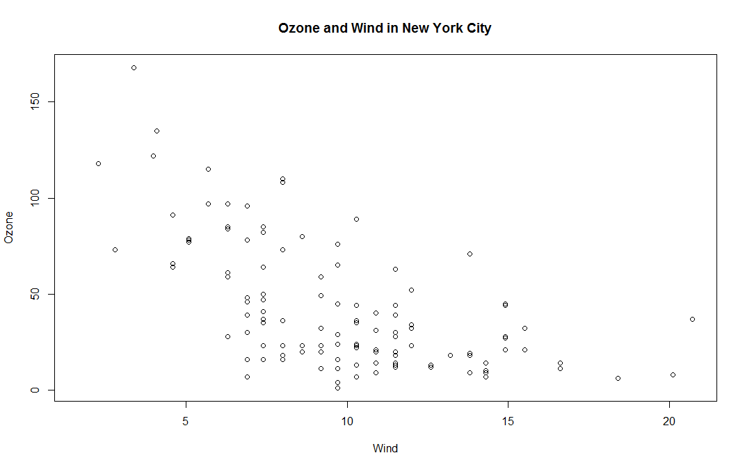

| The basic plotting parameters are documented in the R help page for the function par. You can use par to

| set parameters OR to find out what values are already set. To see just how much flexibility you have, run

| the R command length with the argument par() now.

> length(par())

[1] 72

| Keep working like that and you'll get there!

|================================= | 35%

| So there are a boatload (72) of parameters that par() gives you access to. Run the R function names with

| par() as its argument to see what these parameters are.

> names(par())

[1] "xlog" "ylog" "adj" "ann" "ask" "bg" "bty" "cex"

[9] "cex.axis" "cex.lab" "cex.main" "cex.sub" "cin" "col" "col.axis" "col.lab"

[17] "col.main" "col.sub" "cra" "crt" "csi" "cxy" "din" "err"

[25] "family" "fg" "fig" "fin" "font" "font.axis" "font.lab" "font.main"

[33] "font.sub" "lab" "las" "lend" "lheight" "ljoin" "lmitre" "lty"

[41] "lwd" "mai" "mar" "mex" "mfcol" "mfg" "mfrow" "mgp"

[49] "mkh" "new" "oma" "omd" "omi" "page" "pch" "pin"

[57] "plt" "ps" "pty" "smo" "srt" "tck" "tcl" "usr"

[65] "xaxp" "xaxs" "xaxt" "xpd" "yaxp" "yaxs" "yaxt" "ylbias"

| Keep up the great work!

|================================== | 36%

| Variety is the spice of life. You might recognize some of these such as col and lwd from previous swirl

| lessons. You can always run ?par to see what they do. For now, run the command par()$pin and see what you

| get.

> par()$pin

[1] 4.249444 1.755000

| That's the answer I was looking for.

|==================================== | 38%

| Alternatively, you could have gotten the same result by running par("pin") or par('pin')). What do you

| think these two numbers represent?

1: Random numbers

2: Coordinates of the center of the plot window

3: A confidence interval

4: Plot dimensions in inches

Selection: 4

| Perseverance, that's the answer.

|===================================== | 39%

| Now, run the command par("fg") or or par('fg') or par()$fg and see what you get.

> par("fg")

[1] "black"

| You're the best!

|====================================== | 41%

| It gave you a color, right? Since par()$fg specifies foreground color, what do you think par()$bg

| specifies?

1: Beautiful color

2: blue-green

3: Better color

4: Background color

Selection: 4

| Excellent job!

|======================================== | 42%

| Many base plotting functions share a set of parameters. We'll go through some of the more commonly used

| ones now. See if you can tell what they do from their names.

...

|========================================= | 44%

| What do you think the graphical parameter pch controls?

1: point control height

2: pc help

3: picture characteristics

4: plot character

Selection: 4

| You are doing so well!

|=========================================== | 45%

| The plot character default is the open circle, but it "can either be a single character or an integer code

| for one of a set of graphics symbols." Run the command par("pch") to see the integer value of the default.

| When you need to, you can use R's Documentation (?pch) to find what the other values mean.

> par("pch")

[1] 1

| You're the best!

|============================================ | 47%

| So 1 is the code for the open circle. What do you think the graphical parameters lty and lwd control

| respectively?

1: line length and width

2: line width and type

3: line type and width

4: line slope and intercept

Selection: 3

| You're the best!

|============================================== | 48%

| Run the command par("lty") to see the default line type.

> par("lty")

[1] "solid"

| You're the best!

|=============================================== | 50%

| So the default line type is solid, but it can be dashed, dotted, etc. Once again, R's ?par documentation

| will tell you what other line types are available. The line width is a positive integer; the default value

| is 1.

...

|================================================ | 52%

| We've seen a lot of examples of col, the plotting color, specified as a number, string, or hex code; the

| colors() function gives you a vector of colors by name.

...

|================================================== | 53%

| What do you think the graphical parameters xlab and ylab control respectively?

1: labels for the x- and y- axes

2: labels for the y- and x- axes

Selection: 1

| Great job!

|=================================================== | 55%

| The par() function is used to specify global graphics parameters that affect all plots in an R session.

| (Use dev.off or plot.new to reset to the defaults.) These parameters can be overridden when specified as

| arguments to specific plotting functions. These include las (the orientation of the axis labels on the

| plot), bg (background color), mar (margin size), oma (outer margin size), mfrow and mfcol (number of plots

| per row, column).

...

|===================================================== | 56%

| The last two, mfrow and mfcol, both deal with multiple plots in that they specify the number of plots per

| row and column. The difference between them is the order in which they fill the plot matrix. The call

| mfrow will fill the rows first while mfcol fills the columns first.

...

|====================================================== | 58%

| So to reiterate, first call a basic plotting routine. For instance, plot makes a scatterplot or other type

| of plot depending on the class of the object being plotted.

...

|======================================================== | 59%

| As we've seen, R provides several annotating functions. Which of the following is NOT one of them?

1: points

2: hist

3: lines

4: title

5: text

Selection: 2

| You are amazing!

|========================================================= | 61%

| So you can add text, title, points, and lines to an existing plot. To add lines, you give a vector of x

| values and a corresponding vector of y values (or a 2-column matrix); the function lines just connects the

| dots. The function text adds text labels to a plot using specified x, y coordinates.

...

|========================================================== | 62%

| The function title adds annotations. These include x- and y- axis labels, title, subtitle, and outer

| margin. Two other annotating functions are mtext which adds arbitrary text to either the outer or inner

| margins of the plot and axis which adds axis ticks and labels. Another useful function is legend which

| explains to the reader what the symbols your plot uses mean.

...

|============================================================ | 64%

| Before we close, let's test your ability to make a somewhat complicated scatterplot. First run plot with 3

| arguments. airquality$Wind, airquality$Ozone, and type set equal to "n". This tells R to set up the plot

| but not to put the data in it.

> plot(airquality$Wind, airquality$Ozone, type = "n")

| That's correct!

|============================================================= | 65%

| Now for the test. (You might need to check R's documentation for some of these.) Add a title with the

| argument main set equal to the string "Wind and Ozone in NYC"

> title(main = "Wind and Ozone in NYC")

| You nailed it! Good job!

|=============================================================== | 67%

| Now create a variable called may by subsetting airquality appropriately. (Recall that the data specifies

| months by number and May is the fifth month of the year.)

> may <- subset(airquality, Month == 5)

| Keep working like that and you'll get there!

|================================================================ | 68%

| Now use the R command points to plot May's wind and ozone (in that order) as solid blue triangles. You

| have to set the color and plot character with two separate arguments. Note we use points because we're

| adding to an existing plot.

> points(may$Wind, may$Ozone, col = "blue", pch = 17)

| You are quite good my friend!

|================================================================== | 70%

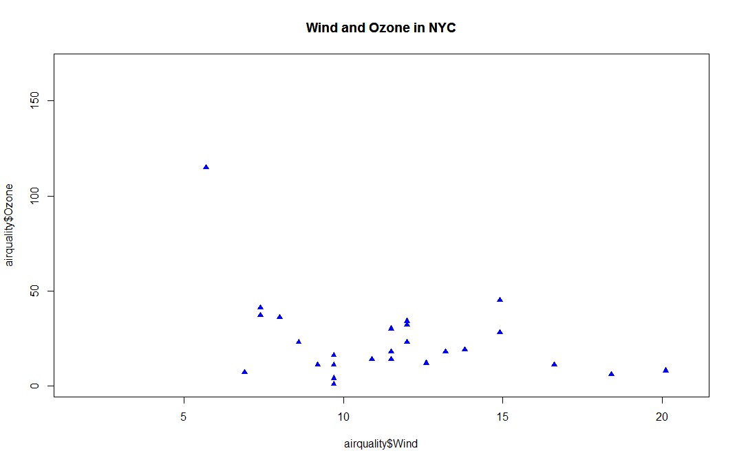

| Now create the variable notmay by subsetting airquality appropriately.

> notmay <- subset(airquality, Month != 5)

| That's correct!

|=================================================================== | 71%

| Now use the R command points to plot these notmay's wind and ozone (in that order) as red snowflakes.

> points(notmay$Wind, notmay$Ozone, col = "red", pch = 8)

| Your dedication is inspiring!

|==================================================================== | 73%

| Now we'll use the R command legend to clarify the plot and explain what it means. The function has a lot

| of arguments, but we'll only use 4. The first will be the string "topright" to tell R where to put the

| legend. The remaining 3 arguments will each be 2-long vectors created by R's concatenate function, e.g.,

| c(). These arguments are pch, col, and legend. The first is the vector (17,8), the second ("blue","red"),

| and the third ("May","Other Months"). Try it now.

> legend("topright", pch = c(17, 8), col = c("blue", "red"), legend = c("May", "Other Months"))

| You got it!

|====================================================================== | 74%

| Now add a vertical line at the median of airquality$Wind. Make it dashed (lty=2) with a width of 2.

> abline(v = median(airquality$Wind), lty = 2, lwd = 2)

| Keep up the great work!

|======================================================================= | 76%

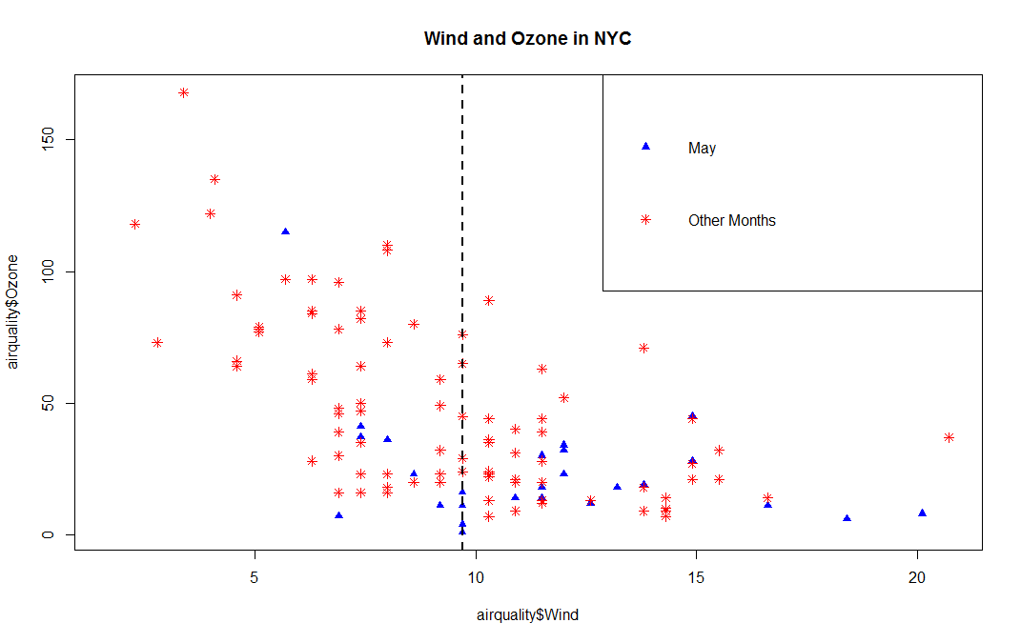

| Use par with the parameter mfrow set equal to the vector (1,2) to set up the plot window for two plots

| side by side. You won't see a result.

> par(mfrow = c(1, 2))

| Perseverance, that's the answer.

|========================================================================= | 77%

| Now plot airquality$Wind and airquality$Ozone and use main to specify the title "Ozone and Wind".

> plot(airquality$Wind, airquality$Ozone, main = "Ozone and Wind")

| Keep working like that and you'll get there!

|========================================================================== | 79%

| Now for the second plot.

...

|=========================================================================== | 80%

| Plot airquality$Ozone and airquality$Solar.R and use main to specify the title "Ozone and Solar

| Radiation".

> plot(airquality$Ozone, airquality$Solar.R, main = "Ozone and Solar Radiation")

| You are quite good my friend!

|============================================================================= | 82%

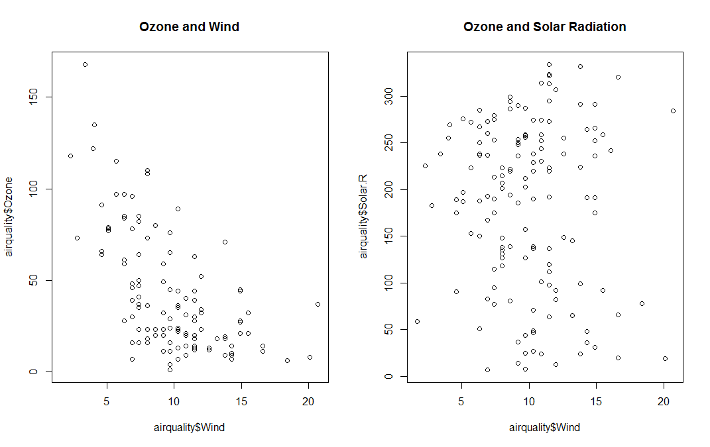

| Now for something more challenging.

...

|============================================================================== | 83%

| This one with 3 plots, to illustrate inner and outer margins. First, set up the plot window by typing

| par(mfrow = c(1, 3), mar = c(4, 4, 2, 1), oma = c(0, 0, 2, 0))

> par(mfrow = c(1, 3), mar = c(4, 4, 2, 1), oma = c(0, 0, 2, 0))

| You got it right!

|================================================================================ | 85%

| Margins are specified as 4-long vectors of integers. Each number tells how many lines of text to leave at

| each side. The numbers are assigned clockwise starting at the bottom. The default for the inner margin is

| c(5.1, 4.1, 4.1, 2.1) so you can see we reduced each of these so we'll have room for some outer text.

...

|================================================================================= | 86%

| The first plot should be familiar. Plot airquality$Wind and airquality$Ozone with the title (argument

| main) as "Ozone and Wind".

> plot(airquality$Wind, airquality$Ozone, main = "Ozone and Wind")

| Nice work!

|=================================================================================== | 88%

| The second plot is similar.

...

|==================================================================================== | 89%

| Plot airquality$Solar.R and airquality$Ozone with the title (argument main) as "Ozone and Solar

| Radiation".

> plot(airquality$Solar.R, airquality$Ozone, main = "Ozone and Solar Radiation")

| That's a job well done!

|===================================================================================== | 91%

| Now for the final panel.

...

|======================================================================================= | 92%

| Plot airquality$Temp and airquality$Ozone with the title (argument main) as "Ozone and Temperature".

> plot(airquality$Temp, airquality$Ozone, main = "Ozone and Temperature")

| Keep up the great work!

|======================================================================================== | 94%

| Now we'll put in a title.

...

|========================================================================================== | 95%

| Since this is the main title, we specify it with the R command mtext. Call mtext with the string "Ozone

| and Weather in New York City" and the argument outer set equal to TRUE.

> mtext("Ozone and Weather in New York City", outer = TRUE)

| Excellent work!

|=========================================================================================== | 97%

| Voila! Beautiful, right?

...

|============================================================================================= | 98%

| Congrats! You've weathered this lesson nicely and passed out of the No!zone.

...

|==============================================================================================| 100%

